J. Patrick Lacher

Engineering 10112-02

In-Class Activity: Plot Pracitce

January 20, 2015

The below graph (fig. 1) represents the results of an experiment involving the equation y=cos(2x\*pi/L) with L=5 for this experiment.

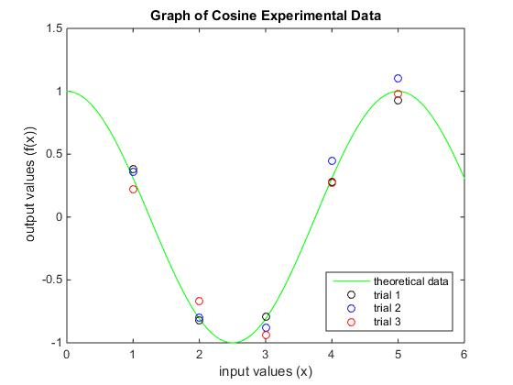

Fig. 1- The graph of experimental data involving the cosine equation.